Research Paper on Course’s recommendation system using AWS sage maker
Ajay Yadav¹and prof. Altaf Shah²

Student, School of Computer Science and Engineering, Ajeenkya D Y Patil University, Pune, India
Ajay.yadav@adypu.edu.in

Assistant Professor, School of Computer Science and Engineering, Ajeenkya D Y Patil University, Pune, India
altaf.shah@inurture.co.in

Abstract. Netflix and YouTube both makes recommendations, Recommendation (RS) programs support users once engineers of various computer programs and software to overcome overload of data, create details acquisition functions and approximate numbers, among others. Research plans are always based on Comparing predictive accuracy: improved testing scores, better recommendation.Why not apply these same basic/simple principles to build a similar system which will recommend the courses to the students which are in need of courses? The recommendation system has the ability to predict whether a particular user may like something or not depending on the user profile.
Keywords: Courses, Recommendation system, Machine Learning, AWS
1 Introduction
The rapid growth in the amount of digital information available and the number of Internet users has created a potential challenge for information overload, which prevents timely responses to online interests.

This has resulted in a higher-than-ever demand for recommendation systems. Recommendation systems are filtering programs that deal with the problem of information overload by separating important pieces of information from a massive amount of data produced dynamically based on the inclination, desires, or perceived behavior of a specific object. Based on the end user profile, the recommendation framework has the ability to determine whether a particular user would like anything or not.

Companies that use recommender programs aim to increase revenue by providing highly customized deals and a better customer experience.

Recommendations usually speed up searches and make it easier for consumers to find content they're interested in, as well as surprising them with deals they wouldn't have found otherwise.

Furthermore, businesses can attract and keep consumers by sending out emails with links to new deals that are relevant to the recipients' interests, or recommendations for films and TV shows that are appropriate for their profiles. The consumer begins to feel recognized and understood, increasing their likelihood of purchasing additional items or consuming more content.

The business gains a competitive advantage by understanding what a consumer wants, and the risk of losing a customer to a rival is reduced. It’s appealing to provide that added value to consumers by including suggestions in systems and products. Furthermore, it enables businesses to stay ahead of their rivals and, as a result, maximize their profits.

These systems make suggestions based on a user's item and profile information. They believe that if a consumer was interested in anything previously, they would be interested in it again in the future. Similar objects are usually grouped together based on their characteristics. User profiles are generated by analyzing previous experiences or by asking users directly about their interests.

There are other programs that use consumer personal and social data that aren't considered strictly content-based.

One problem that occurs as a result of unnecessary specialization is making obvious recommendations (user A is only interested in categories B, C, and D, and the system is not able to recommend items outside those categories, even though they could be interesting to them).

Another common issue is that new users do not have a specified profile unless they are specifically asked for one. Nonetheless, adding new objects to the system is relatively easy. All we have to do now is appoint them to a category based on their characteristics. New deep learning approaches are constantly being adopted by recommender programs in order to extract even more strength from the data we have in order to have a better user experience.

The data is the most important resource. It's time to take the requisite steps to manage and store it properly if you aren't already. When you get to the implementation point, you'll need to delve much deeper into the issue. The type of recommender system you should concentrate on first will be determined by your business goals: whether you want to increase interaction with already active users or encourage infrequent consumers to become more active.

Aside from identifying the business objective, you must be able to analyze and comprehend the data produced by your website. Given that, nothing can stand in the way of your recommender system's effective implementation.

2 Literature Review
2.1 Literature Review Table

Table I: Literature Survey

Sr.  No. | Title of Research  Paper (year of publication) | Author | Methodology | Strengths | Drawback | Future Scope
1. | Course Recommender System Based on Graduating Attributes | Behdad Bankshinategh,  Gerasimos Spanakis | graduating attributes of student are used | More accurate recommendation using synthetic datasets | Challenges to achieve  scalability | Change the context based algo. To CF algo. Overtime.
2. | Automated Recommender System for Course Selection | Amer Al-Badarenah  Jamal Alsakran | Automatically find similar students and then apply association rule mining algorithm on their courses to create courses association rules. | Employed association rules algorithm to recommend university elective courses to a target student based on what other similar students have taken. | If multiple students try to get similar courses the other best courses will not be in recommendations. | Future more experiments will be performed with the content-based recommendations.
3. | Enrollment Recommender System | Hana Bydžovská | Algorithm based on similarity of interesting courses reached the best results. | Used multiple algorithms that makes the system more robust and functional. | Have to maintain the balance between the four algorithms | The designed enrollment recommender system will be a part of the university information system in the future.

Sr.  No. | Title of Research  Paper (year of publication) | Author | Methodology | Strengths | Drawback | Future Scope
4. | A Web-Based Prototype Course Recommender System using Apache Mahout | Mike Nkongolo | Trial and error methods were multiple algorithm  (hybrid system) | More accurate recommendation Machine learning | Challenges to  Gain appropriate amount of data analysis | System should be there for the unique courses should be given the to students which wants to learn something unique.
5. | Designing a Course Recommendation System on Web based on the Students' Course Selection Records | Ko-Kang Chu,  Maiga Chang  Yen-Teh Hsia2 | Algorithm is designed for merging two directed graphs | By using our recommendation process, the preference sequence of students can be generated. With the sequence, the most appropriate courses then are able to find out for making suggestions to students. | Still have issues in proper accuracy till now but got some accuracy | Time series analysis should be made, which means can we predict the students’ change of interest from year to year.

2.2 Literature Review Description

Following is a summary of existing work.

One of the research issues that receives a lot of attention in higher education institutions around the world is ensuring that students achieve the expected learning outcomes (ILO) set by various programs. [1] These ILOs are connected to "competencies" needed to complete specific tasks within programs. It does not have to be restricted to the classroom; it can also include activities and the whole university experience. When it comes to the above, these competencies relate to attributes that are specifically related to a specific institution's overall vision and purpose.

“Graduate attributes are the strengths, abilities, and understandings that a university group agrees should be developed by its students during their time there. These characteristics include, but are not limited to, disciplinary experience or technical skills, which have historically been at the center of most university courses. They are also characteristics that train graduates to be agents of social good in the future.”

Universities have established their respective GAs over the last two decades, but ensuring that they are obtained has proved difficult. For evaluating GAs, Ipperciel and ElAtia proposed a dynamic model (Ipperciel and ElAtia, 2014). This model is based on rubrics linked to the can-do statement, where they implemented a 1 to 5 likert scale for measuring each of the Graduate Attributes and their sub-attributes. The five stages of the scale are emergent, fundamental, sufficient, superior, and exceptional.

This evaluation model is focused on teachers and students interacting with specific courses and ILOs. Students and teachers may use the model to conduct self-assessment based on their own experiences and interactions with course materials.

A course recommender framework based on students' graduating attributes was presented in this paper. The proposed method is in the field of time-aware multi-criteria course recommender systems for students, which has never been attempted in educational data mining before. Experimenting on real data will first present new problems, but it will also help to validate the proposed algorithm. Compatibility with the institution's program plans is one of the challenges. For example, a recommender system should take into consideration the pre-requisites of each program's courses.

Experiments on a synthetic dataset show that the time dimension of student ratings is crucial for more precise recommendations, and that the active neighborhood of students used can be significantly reduced. New options for the algorithm's logic will be available in light of this issue. For example, the algorithm will be required to suggest a low-value course in order to satisfy the prerequisites for a valuable course. The algorithm's scalability poses a second problem. To provide a fair response time for making recommendations to a large number of students, new techniques may be required.

One avenue to investigate is the clustering of similar students in order to suggest courses based on clusters of similar students rather than the entire dataset. We can look at a smaller collection of students without sacrificing precision, based on the results of our correlation thresholding.

Finally, other collaborative filtering algorithms (such as matrix factorization) will be investigated, as well as ways to improve efficiency. The cold start problem is a concern that should be addressed in the context of recommender systems.

One way to change is to use content-based algorithms in the first few semesters and then give the CF algorithm more weight as time goes on.

[2] The majority of electronic commerce and knowledge management systems depend on recommender systems to classify a collection of products that would be of interest to a specific consumer. Things are recommended by collaborative recommender systems based on similarities and differences between users' preferences. The aim of this paper is to present a collaborative recommender framework for university elective courses. The majority of electronic commerce and knowledge management systems depend on recommender systems to identify a group of items that may be of interest to a particular customer. Collaborative recommender systems make recommendations based on consumer interests' similarities and differences. The aim of this paper is to present a structure for collaborative university recommender systems. An association rules mining algorithm is used in the proposed framework.as a foundation for discovering trends between courses. Experiments with real datasets were carried out to determine the effectiveness of the method. overall effectiveness of the suggested method.

This paper's key contribution is a new collaborative recommendation framework that uses an association rules algorithm to suggest university elective courses to a target student based on what other similar students have taken. The experiments revealed that using an association rule to make recommendations to a target student is a useful method. As a result of our efforts, during our research, we discovered patterns of influence from various sources. Parameters on the system's results.

A rule's confidence and match have a significant effect on results, but the highest confidence or match might not be the best option.
We may boost our performance by selecting a reasonably high confidence or match.

[3] We demonstrated a pilot version of a course enrollment recommender system that reminds students of their commitments, alerts them about challenging courses, and suggests courses that could be beneficial. As a result, during the admission process at the start of each semester, the system supports students with their decisions. In particular, we created four algorithms that are suitable for course recommendation. The first algorithm looks for the courses that are most commonly taken. The second algorithm takes advantage of student similarities based on courses that they are interested in.

The third algorithm suggests courses taught by students' favorite professors. The final algorithm measures the social relations between people. students and chosen courses that students' friends would be interested in. The first mentioned algorithm was the most appropriate for selective course recommendation. Students usually choose simpler courses from their models. The second algorithm, which uses students' similarities, showed the best results for the optional course recommendation.

Let’s have a look on the importance of the problem which is explained in paper [4].

The topic addressed can be summarized in two ways: students' satisfaction with their courses and their probability of academic achievement. These two variables obviously have consequences not only for students, but also for the university they attend. A student who is dissatisfied with the content of a course may choose to withdraw from it. This could mean that the student would have to wait until the next semester or year to register for another course, losing even more time.

Any self-funding students who chose to leave the university would result in a loss of tuition that would have been charged, not just in that year, but in future years as well. Furthermore, negative feedback from disgruntled students may influence prospective students' decisions to not enroll in a course or attend a specific university.

The main aim of recommender systems is to make useful determinations about potential ties between the system's user and certain artifacts or things based on cleaned input data, and then to output these relevant findings. Depending on whether the individual is looking for a list of recommendations or a prediction, these outputs can take the form of an ordered list or a single value [Vozalis and Margaritis 2003]. These outcomes or outputs can then be used to assist the consumer in making decisions.

At the University of the Witwatersrand, a web-based interactive recommender framework will be introduced to recommend courses to first-year Computer Science students.

This paper has developed a web-based course recommendation framework. If students are having difficulty deciding which courses to take, they can use a course recommendation system to support them. [5] This paper develops a recommendation framework based on our previously proposed Prediction Methodology.

The prediction approach combines both Data Mining and Graph Theory techniques, which will be disclosed in this paper for readers to gain an understanding of how we can make effective course recommendations for students.

3 Architecture / Flowchart

The proposed system overview consists of the following steps as shown in Figures.

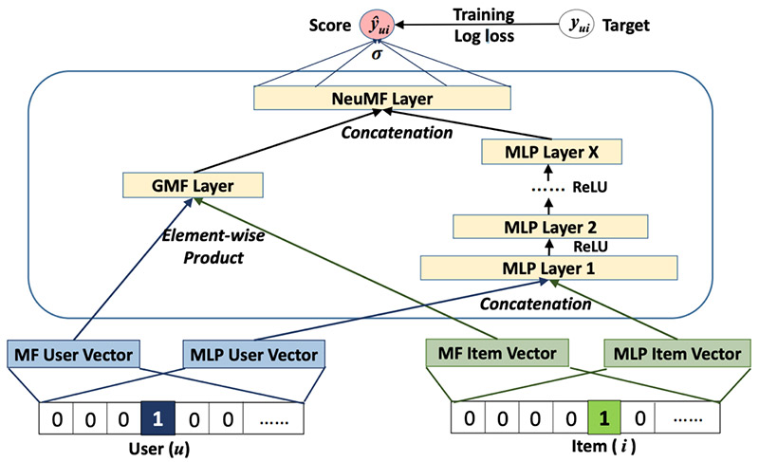

Fig 1: NFC model

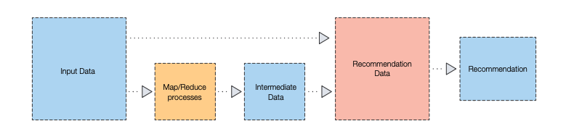
Fig 2: Data flow Diagram

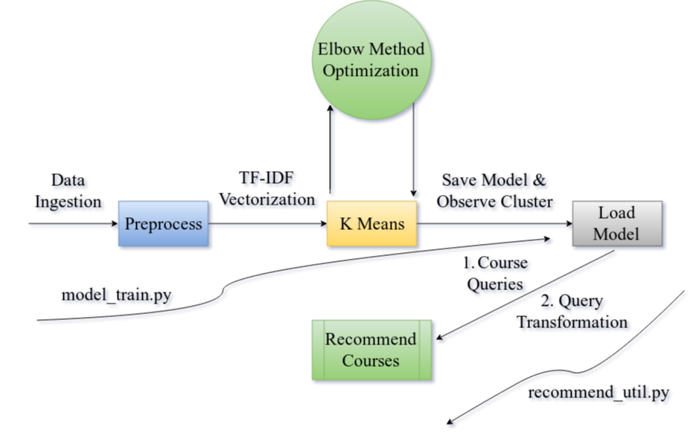

Fig 3: Work flow Diagram

4 Proposed Methodology

Netflix makes suggestions based on your viewing history, what other members of similar interests are watching, and movie metadata like genre, categories, and more. The same concepts can be applied to study recommendations with ease. I'll keep track of our course metadata and watch history. The only thing that was lacking was a simple way to compare students to see if they had similar interests. Thankfully, compiled, a machine learning process, can be used to classify each student into a specific category.

Our chosen machine learning technique, which enabled us to group (or cluster) like students, was critical to making this solution work. There are a number of machines learning methods and learning algorithms to choose from (supervised, unsupervised, reinforcement, transition, and so on).

We chose our technique and learning algorithm based on the data we had access to and the results we predicted (i.e., groupings of students).

Since our data was not classified, I chose unsupervised learning as our technique and K-means as our learning algorithm because we needed to divide our students into a particular number (or k number) of clusters (or groups) based on similarities.

Amazon SageMaker was our method of choice for developing the machine learning model. Amazon SageMaker was chosen because it offers compute instances that run Jupyter Notebooks. Fortunately, SageMaker took care of setting up the instance and all of the necessary tools. To prepare our data and run the clustering algorithm, we used our notebook case.

My primary tool is Amazon's Sage Creator program, which includes all of the required machine learning features such as training and sample algorithms.

Both service providers and consumers benefit from recommendation services. They lower the costs of searching for and choosing products in the online shopping market. Recommendation systems have also been shown to increase the consistency and method of decision-making.

The learning algorithm then groups (or clusters) students into learning groups based on the similarities it finds.

5 Expected Outcome

So, how does it function? The progress a student has made on courses in categories like AWS, Python, containers, DevOps, machine learning, and more is fed into the K-means learning algorithm.

The learning algorithm then groups (or clusters) students into learning groups based on the similarities it finds. Consider it this way: each student is evaluated through a magical funnel. A student's location in a learning group (or cluster) is determined by the magic funnel.

We are left with distinct groups after the machine learning algorithm tests each pupil.
Having accurate data is the most critical feature of a machine learning project.

The data points are a great place to start. Despite the fact that we have this info, the files aren't good enough for a computer to learn from. We must process and prepare the data in order for the learning algorithm to identify trends and patterns quickly. We launched a SageMaker Jupyter hosted notebook instance and started writing Python code because SageMaker is versatile enough to allow us to do so.

There are various ways to investigate and learn about your data. To better understand our results, we wanted to use Matplotlib — a Python-based data visualization library — and other techniques, specifically searching for trends and outliers.

We begin the training process with the K-means learning algorithm now that we have the data in a format that a machine learning algorithm can understand. We chose Scikit-learn because its K-means implementation is quick and effective for our dataset, and it is very easy to learn for beginners.

Then we looked at the courses that students in that cluster had watched and learned. To arrive at this conclusion, we used a watch percentage of more than 90%.

At last the expected outcome of this projects is that we will get a system which will work as the recommendation system for the students which are need of any sources of studying.

6 Result

We begin the training process with the K-means learning algorithm now that we have the data in a format that a machine learning algorithm can understand. We chose Scikit-learn because its K-means implementation is quick and effective for our dataset, and it is very easy to learn for beginners. The learning algorithm then groups (or clusters) students into learning groups based on the similarities it finds. Consider it this way: each student is evaluated through a magical funnel. A student's location in a learning group (or cluster) is determined by the magic funnel.

7 Conclusion

We will recommend courses to each student based on their assigned cluster when they enter the platform now that we know which cluster they are assigned to and the course categories associated with that cluster. If the logged-in system the clusters will, for example, we'll suggest courses in AWS, Certification, Cloud, Creation, Serverless, Programming, Database, and AI.

This advice takes into account what they've watched and learned, as well as what their cluster members have learned. At last the expected outcome of this projects is that we will get a system which will work as the recommendation system for the students which are need of any sources of studying.

At last we gonna have a system which will change the world of students who want to learn new things and can get courses according to there history, interest, and knowledge backgrounds.

References

[1] | https://www.researchgate.net/publication/317121166_  A_Course_Recommender_System_based_on_Graduating_Attributes
[2] | https://thesai.org/Downloads/Volume7No3/Paper_23-An_Automated_Recommender_System_for_Course_Selection.pdf

[3] https://files.eric.ed.gov/fulltext/ED592681.pdf

[4] https://www.grin.com/document/375739

[5] https://www.semanticscholar.org/paper/Designing-a-Course-Recommendation- System-on-Web-on-Chu-Chang/42ac45919b606fedd33e7a04d9cbc41c7f39d718

[6] https://arxiv.org/pdf/1309.6908

[7] https://ieeexplore.ieee.org/abstract/document/4722931/

[8] https://ieeexplore.ieee.org/abstract/document/7124857/

[9] https://dl.acm.org/doi/abs/10.1145/358916.358994

[10] https://link.springer.com/article/10.1007/s41870-018-0138-8

